Reg. No.

SRM Institute of Science and Technology
Set D
College of Engineering and Technology
School of Computing
DEPARTMENT OF COMPUTING TECHNOLOGIES
SRM Nagar, Kattankulathur – 603203, Chengalpattu District, Tamilnadu
Academic Year: 2023-2024 (ODD)
Test: CLAT-3 Date: 09.11.2023
Course Code & Title: 18CSE355T - Data Mining and Analytics Duration: 2 Periods
Year & Sem: III Year & 05th Semester Max. Marks: 50 Marks

Part – A (10 x 1 = 10 Marks) Answer all questions.
Q. No | Question | Marks
1 | The process of grouping a set of physical or abstract objects into classes of similar objects is called as _______.  a) Prediction b) Association c) Correlation d) Clustering  Answer:  d) Clustering | 1
2 | Let p1=(3,2) and p2=(4,1) represent two objects, what will be the Euclidean distance?  a) 2.449 b) 2.236 c) 1.414 d) 1.732  Answer:  c) 1.414 | 1
3 | What is the primary assumption made by the K-means clustering algorithm?  a) Clusters have a spherical shape b) Clusters have similar densities  c) Clusters have similar sizes d) Clusters are linearly separable  Answer:  a) Clusters have a spherical shape | 1
4 | _____method removes sparse clusters as outliers and groups dense clusters in to larger ones.  a) DIANA b) BIRCH c) STING d) DBSCAN  Answer:  b) BIRCH | 1
5 | Hierarchical agglomerative clustering is typically visualized using _______.  a) Dendrogram b) Binary trees c) Block diagram d) Graph  Answer:  a) Dendrogram | 1
6 | What does the term 'outlier' mean?  a) A score that is left out of the analysis because of missing data  b) The arithmetic mean  c) A type of variable that cannot be quantified  d) An extreme value at either end of a distribution  Answer:  d) An extreme value at either end of a distribution | 1
7 | In Univariate outlier detection uses the maximum likelihood to estimate which of the following parameter(s)?  i) Mean ii) Median iii) Standard deviation iv) User-specified parameter.  a) (i) and (ii) b) (i) and (iii)  c) (iii) and (iv) d) (ii), (iii) (iv)  Answer:  b) (i) and (iii) | 1
8 | The learning algorithms that can deal with both minimal labelled dataset and large unlabeled dataset together is called _____.  a) Supervised b) Unsupervised c) Semi supervised d) Reinforcement  Answer:  c) Semi supervised | 1
9 | Which of the following data mining application is used to allow the retailer to understand the purchase behaviour of a buyer?  a) Manufacturing Engineering b) Fraud Detection  c) Corporate Surveillance d) Market Basket Analysis  Answer:  d) Market Basket Analysis | 1
10 | Which of the following is an example of a Content-based Recommendation System?  i) Recommending movies to a user based on the movies rated by that user in the past  ii) Recommending the most popular movies  iii) Randomly recommending some selections from a list of movies  a) Only i b) Only ii and iii  c) Only i and iii d) Only ii  Answer:  a) Only i | 1
Part – B
(4 x 5 = 20 Marks)
Answer any 4 Questions
11 | Explain CLIQUE Technique with example.  Answer:  - CLIQUE can be considered as both density- based and grid-based  - It partitions each dimension into the same number of equal length interval  - It partitions an m-dimensional data space into non-overlapping rectangular units  - A unit is dense if the fraction of total data points contained in the unit exceeds the input model parameter  - A cluster is a maximal set of connected dense units within a subspace  The Major Steps  - Partition the data space and find the number of points that lie inside each cell of the partition.  - Identify the subspaces that contain clusters using the Apriori principle  - Identify clusters  - Determine dense units in all subspaces of interests  - Determine connected dense units in all subspaces of interests.  - Generate minimal description for the clusters  - Determine maximal regions that cover a cluster of connected dense units for each cluster  - Determination of minimal cover for each cluster  Strength  - automatically finds subspaces of the highest dimensionality such that high density clusters exist in those subspaces  - insensitive to the order of records in input and does not presume some canonical data distribution  - scales linearly with the size of input and has good scalability as the number of dimensions in the data increases  Weakness  - The accuracy of the clustering result may be degraded at the expense of simplicity of the method | 5
12 | Discuss the Challenges of clustering Data mining.  Key  - Scalability  - Ability to deal with different types of attributes  - Constraint-based clustering  - Interpretability and usability  Above topics with briefing about each. | 5
13 | How to Measure the Clustering Quality? Explain.  Answer:  - Dissimilarity/Similarity metric  Similarity is expressed in terms of a distance function, typically metric: d(i, j)  - The definitions of distance functions are usually rather different for interval-scaled, boolean, categorical, ordinal ratio, and vector variables  - Weights should be associated with different variables based on applications and data semantics  - Quality of clustering:  - There is usually a separate “quality” function that measures the “goodness” of a cluster.  - It is hard to define “similar enough” or “good enough”  - The answer is typically highly subjective | 5
14 | Outline the Challenges of Outlier Detection.  Key Points :  - Modeling normal objects and outliers properly  - Hard to enumerate all possible normal behaviors in an application  - The border between normal and outlier objects is often a gray area  - Application-specific outlier detection  - Choice of distance measure among objects and the model of relationship among objects are often application- dependent  - E.g., clinic data: a small deviation could be an outlier; while in marketing analysis, larger fluctuations  - Handling noise in outlier detection  - Noise may distort the normal objects and blur the distinction between normal objects and outliers. It may help hide outliers and reduce the effectiveness of outlier detection  - Understandability  - Understand why these are outliers: Justification of the detection  - Specify the degree of an outlier: the unlikelihood of the object being generated by a normal mechanism | 5
15 | Discuss about any two Major Statistical Data Mining Methods  Key:  Explanation of any two of the following methods: 2 * 2.5= 5 marks  - Regression  - Generalized Linear Model  - Analysis of Variance  - Mixed-Effect Models  - Factor Analysis  - Discriminant Analysis  - Survival Analysis | 5
Part – C
(2 x 10 = 20 Marks)
Answer All the questions
16 | Briefly Explain the K-Means algorithm and Apply the K-means algorithm for the following five points (with (x, y) representing locations) into two clusters: A1(3, 10), A2(7, 5), A3(10, 4), A4(5, 9), A5(8, 5).  Initial cluster centers are: A1(3, 10), and A4(5, 9)  Use K-Means Algorithm to find the two cluster centers after two iterations.  Note: The distance function between two points a = (x1, y1) and b = (x2, y2) is defined as- Ρ(a, b) = |x2 – x1| + |y2 – y1|  Key:  K-Means Clustering Algorithm – 5 marks  Problem solution – 5 marks  Answer:  K-Means Clustering Algorithm  K-Means Clustering Algorithm involves the following steps-  Step-01:  Choose the number of clusters K.  Step-02:  Randomly select any K data points as cluster centers.  Select cluster centers in such a way that they are as farther as possible from each other.  Step-03:  Calculate the distance between each data point and each cluster center.  The distance may be calculated by using Euclidean distance formula (or by using given distance function in variants of the algorithm).  Step-04:  Assign each data point to some cluster.  A data point is assigned to that cluster whose center is nearest to that data point.  Step-05:  Re-compute the center of newly formed clusters.  The center of a cluster is computed by taking mean of all the data points contained in that cluster.  Step-06:  Keep repeating the procedure from Step-03 to Step-05 until any of the following stopping criteria is met:  Center of newly formed clusters do not change.  Data points remain present in the same cluster Maximum number of iterations are reached.  Problem:  Answer  A1(3, 10), A2(7, 5), A3(10, 4), A4(5, 9), A5(8, 5).  Iteration 1  Initial cluster centers are: A1(3, 10), and A4(5, 9)  Iteration 2  New Cluster centers are: (3, 10), and (30/4=7.5,23/4=5.75)  Iteration 3  New Cluster centers are: (4, 9.5), and (25/3=8.33,14/3=4.67)  Between Iterations 2 and 3 no change.  So, Clusters are:  C1 - A1(3, 10) and A4(5, 9),  C2 - A2(7, 5), A3(10, 4) and A5(8,5). | 10
  Given  Points | Distance  from  center of  Cluster-01 | Distance  from  center of  Cluster-02 | Point  belongs  to Cluster
  A1(3, 10) | 0 | 3 | C1
  A2(7, 5) | 9 | 6 | C2
  A3(10, 4) | 13 | 10 | C2
  A4(5, 9) | 3 | 0 | C2
  A5(8,5) | 10 | 7 | C2
  Given  Points | Distance  from  center of  Cluster-01 | Distance  from  center of  Cluster-02 | Point  belongs  to Cluster
  A1(3, 10) | 0 | 8.75 | C1
  A2(7, 5) | 9 | 1.25 | C2
  A3(10, 4) | 13 | 4.25 | C2
  A4(5, 9) | 3 | 5.75 | C1
  A5(8,5) | 10 | 1.25 | C2
  Given  Points | Distance  from  center of  Cluster-01 | Distance  from  center of  Cluster-02 | Point  belongs  to Cluster
  A1(3, 10) | 1.5 | 10.66 | C1
  A2(7, 5) | 7.5 | 3.66 | C2
  A3(10, 4) | 11.5 | 2.34 | C2
  A4(5, 9) | 1.5 | 7.66 | C1
  A5(8,5) | 8.5 | 0.66 | C2
17 | Outline how to compute dissimilarity between objects described by the following types of variables with example.  i. Interval-Scaled Variable, ii. Binary Variable, iii. Categorical Variable  Answer:  Key Points:  Interval-Scaled Variable  - Interval-scaled variables are continuous measurements of a roughly linear scale. Eg: weight and height  - The measurement unit used can affect the clustering analysis.  - For example, changing measurement units from meters to inches for height, or from kilograms to pounds for weight, may lead to a very different clustering structure.  - To avoid dependence on the choice of measurement units, the data should be standardized.  - Standardizing measurements attempts to give all variables an equal weight.  Data Normalization  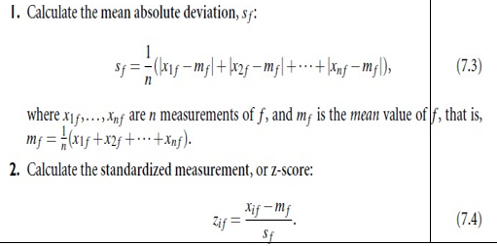  Explanation of Distance measures.  Binary Variable  - The total number of variables is p, where p =  q+r+s+t.  - A binary variable is symmetric if both of its states are equally valuable and carry the same weight.  - There is no preference on which outcome should be coded as 0 or 1.  - Dissimilarity that is based on symmetric binary variables is called symmetric binary dissimilarity.  - A binary variable is asymmetric if the outcomes of the states are not equally important, such as the positive and negative outcomes of a disease test.  - A binary variable contains two possible outcomes: 1 (positive/present) or 0 (negative/absent). If there is no preference for which outcome should be coded as 0 and which as 1, the binary variable is  called symmetric.  - For example, the binary variable "is evergreen?" for a plant has the possible states "loses leaves in winter" and "does not lose leaves in winter." Both are equally valuable and carry the same weight when a proximity measure is computed.  - If the outcomes of a binary variable are not equally important, the binary variable is called asymmetric.  - An example of such a variable is the presence or absence of a relatively rare attribute, such as "is color-blind" for a human being.  - While you say that two people who are color- blind have something in common, you cannot say that people who are not color-blind have something in common.  Categorical Variable  - A categorical variable is a generalization of the binary variable in that it can take on more than two states.  - For example, map color is a categorical variable that may have, say, five states: red,  yellow, green, pink, and blue.  - Let the number of states of a categorical variable be M. The states can be denoted by letters, symbols, or a set of integers, such as 1, 2, : : : , M.  - The dissimilarity between two objects i and j can be computed based on the ratio of mismatches equation  - m - where m is the number of matches (i.e., the number of variables for which i and j are in the same state), and p is the total number of variables.  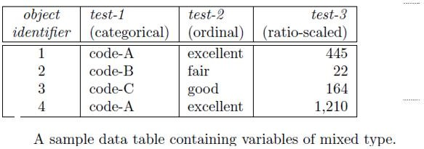  Suppose that we have the sample data of Table except that only the object-identifier and the variable (or attribute) test-1 are available, where test-1 is categorical. Let's compute the dissimilarity matrix.  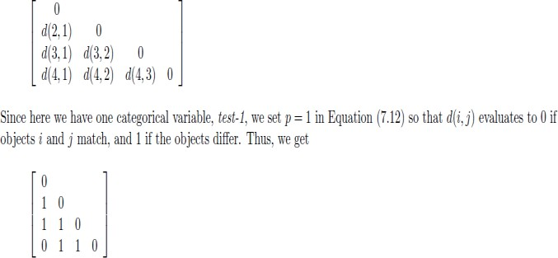 | 10
18 | Discuss in detail the semi-supervised methods for detecting the outliers.  Answer:  Semi Supervised Algorithm for outliers  - Situation: In many applications, the number of labeled data is often small: Labels could be on outliers only, normal objects only, or both  - Semi-supervised outlier detection: Regarded as applications of semi-supervised learning  - If some labeled normal objects are available  - Use the labeled examples and the proximate unlabeled objects to train a model for normal objects  - Those not fitting the model of normal objects are detected as outliers  - If only some labeled outliers are available, a small number of labeled outliers many not cover the possible outliers well  - To improve the quality of outlier detection, one can get help from models for normal objects learned from unsupervised methods  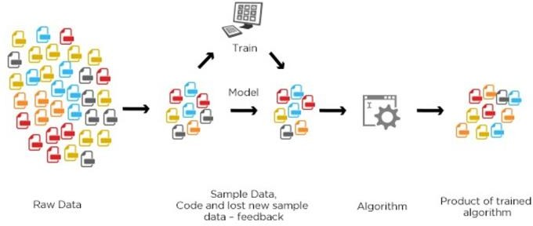 | 10
19 | Outline how data mining algorithms can be used for recommender systems and financial data analysis.  Key:  Recommender system – 5 marks  Financial data analysis – 5 marks  Answer:  Data Mining for Recommender systems  - Personalization, making product recommendations that are likely to be of interest to a user  - Approaches: Content-based, collaborative, or their hybrid  - Content-based: Recommends items that are similar to items the user preferred or queried in the past  - Collaborative filtering: Consider a user's social environment, opinions of other customers who have similar tastes or preferences  - Data mining and recommender systems  - Users C × items S: extract from known to unknown ratings to predict user-item combinations  - Memory-based method often uses k-nearest neighbor approach  - Model-based method uses a collection of ratings to learn a model (e.g., probabilistic models, clustering, Bayesian networks, etc.)  Hybrid approaches integrate both to improve performance (e.g., using ensemble)  Data Mining for Financial Data Analysis  - Financial data collected in banks and financial institutions are often relatively complete, reliable, and of high quality  - Design and construction of data warehouses for multidimensional data analysis and data mining  - View the debt and revenue changes by month, by region, by sector, and by other factors  - Access statistical information such as max, min, total, average, trend, etc.  - Loan payment prediction/consumer credit policy analysis  - feature selection and attribute relevance ranking  - Loan payment performance  - Consumer credit rating  - Classification and clustering of customers for targeted marketing  - multidimensional segmentation by nearest-neighbor, classification, decision trees, etc. to identify customer groups or associate a new customer to an appropriate customer group  - Detection of money laundering and other financial crimes  - integration of from multiple DBs (e.g., bank transactions, federal/state crime history DBs)  - Tools: data visualization, linkage analysis, classification, clustering tools, outlier analysis, and sequential pattern analysis tools (find unusual access sequences) | 10

